**PROJECT REPORT**

**Course Name/Code:**

Computer Communication And Networks

**Project Title:**

Network Studying Of an Organization.

**Organization Name:**

International Multiple group of Companies

**Submitted To:**

**Project Members:**

**INTRODUCTION**

Our Project is on maintaining a Network in the IMGC Global pvt Limited. IMGC is a progressive Business House operating out of Pakistan with offices all over Pakistan and in key regions of the world. IMGC started its operations in 1984 with a small dates processing factory in Islamabad. In the last 25 years IMGC has emerged as one of the largest manufacturers of edible oil in Pakistan with manufacturing units in Nowshera, Multan and Karachi. IMGC is also one of the leading providers of materials and services to governmental, non-governmental organizations, UN agencies and private development corporations for their respective projects all over the world. Besides its business activities, IMGC is also involved in a number of community development projects to share its success with the people who are in need of assistance. We have two floor Building and we want to maintain a Network for the Building.

**Scope of Project:**

We have to study the Network of “IMGC”. We have to find the following points of the network.

1. We have to map the network.
2. The total numbers of hosts.
3. Network devices that are using in the network.
4. Name of devices
5. The current market price of devices.

**Network Information:**

IMGC using 42 PC that’s are connecting through 2 switches and switches Connect through 1 router. IMGC using 2 internet connections DSL and NAYATEL.IMGC only use one connection at time when problem come in one connection they use other and save their loss due to communication breakdown of internet. The class “C” address is using in the IP addresses 192. - . - .

**Total Number of PC’s**

**First Floor**

* 2 pc’s for executive room
* 5 pcs for procurement room
* 9 pcs for staff room
* 7 pcs construction room

**Second Floor**

* 1pc for executive room(chairman room)
* 5pc’s for finance room
* 7pc’s for general room
* 3 pc’s for admin room
* 1pc for executive room(Vice chairman room)

**Other Equipment’s**

* Router

1 Router is used for connecting two switches and router is present in 1st floor within staff room.

* Switches

2 Switches is used for connecting all pc’s,1 switch is used in 1st floor and all pc’s are directly connect with them.2nd switch is present in 2nd floor and all 2nd floor pc’s is connected with them.2nd floor switch is connect with router in 1st floor through wire.

**Building Network Map in Visio:**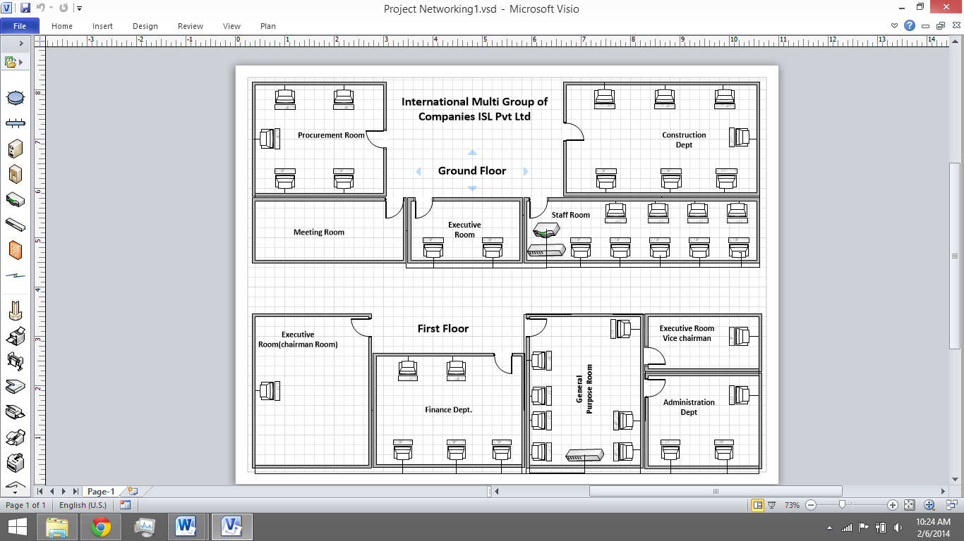

**Network Map in Packet Tracer:**

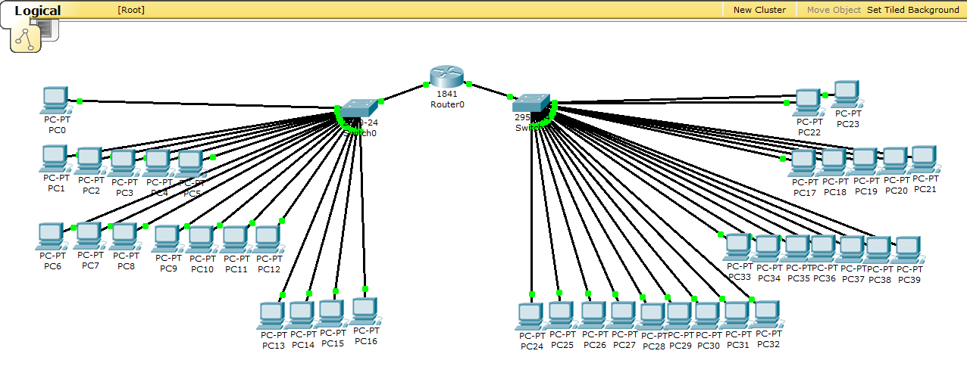

IMGC company use 23 pc’s in ground floor and 17 pc’s in 1st floor. Using subnetting ,Configuring 1st floor 17 pc’s with gateway ip 192.168.1.1 because router interface with these pc’s switch is at 192.168.1.1 so use this ip as a default gateway and ground floor pc’s with gateway ip 192.168.2.1 because these pc’s switch is using interface with router is 192.168.2.1.using subnetting to configure both switches with router.

**Price:**

**CAT 6 Cable**

➢ $150

➢ Available/In Stock

➢ 2000 feet

➢ Maintained by Computer Services as needed

**Switch 24-ports**

➢ $180.00(2 switches price)

➢ Available/In Stock

➢ 24-ports

➢ Maintained by Computer Services as needed

**Router:**

➢ $120.00

➢ Available/In Stock

**Total Cost**

➢ $450.00